
Royal Weave Report

Team Member’s Name | Team Member’s ID | Team Member’s Signature
Abdulmohsen Almansour |  | 
Ziyad Alshami
Turki Al-Abdulgader |  | 
Tamim Alsuhibani | 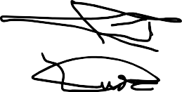
Mohammed ALjubran

Major: CS Class: 8MS3 | Group: 7
Date of Submission: 17th May 2026

Contents
1. Introduction 4
2. Overview 4
3. Database 4
3.1 Database design overview 4
3.2 Tables Structure 4
3.3 Entity-Relationship Design 5
4. User Features 7
4.1 Product Listing 7
4.2 Product Details Page 7
4.3 Cart and Checkout 8
4.4 Navigation Flow 8
4.5 User Account and Purchase History 9
4.6 Contact Us Page 9
5. Admin Features 9
5.1 Product Management 9
5.2 Search Functionality 10
5.3 Admin Navigation Flow 10
5.4 Admin Input Validation 10
5.5 Admin Logout 10
6. Fulfilled Requirements 11
6.1 Description 11
6.2 JavaScript Validation 11
6.3 Tasks That Are Not Included 11
7. Testing Cases 13
7.1 Testing Table 13
8. Project Implications 16
8.1 Description 16
8.2 Development process 16
8.3 Future Expansion 17
9. Teamwork and Contribution 17
10. Conclusion 17

Introduction
This report presents the full development journey of Royal Weave, a shopping web-based system that started as a front-end prototype using HTML and CSS, then expanded into a more functional e-commerce website using PHP, JavaScript and a database. The project was designed to simulate the main features of an online shopping platform, including product browsing, product details, cart management, checkout, user accounts, purchase history and an admin control panel.

Overview
Royal Weave provides a simple and intuitive shopping experience where users can browse products, view product details, manage their cart and complete checkout. The system also includes user account features such as login, signup, profile editing and purchase history. On the admin side, the website includes a control panel that allows admins to manage products, update product information, control product status and search for products efficiently.

Database

Database design overview
The database is designed using a relational model to ensure data consistency and integrity. It supports all core functionalities of a database system. Managing users, admins, products and orders. Design follows a normalized principle reducing redundancy and aims to reach an
efficient relationship.

Tables Structure
Databases consist of interconnected tables with each serving a role. In royal weave we designed the table structure to separate responsibilities across user, product and order management.
    - Admin and Customer tables: These tables store account information for both admins and users. Crucial for separating system control.
    - Category and Product tables: These tables organize product data and classify them into categories.
    - Product Variant Table: This table stores variant details such as price, stock quantity, size, color and image.
    - Orders and Order items tables: These tables store the checkout process by storing cart information, completed orders, quantities and prices.

    - User session and Activity Log tables: These tables record and store login sessions and activities. Such as viewing products, adding items to carts and placing orders. Tracking user behavior ensuring better experience.
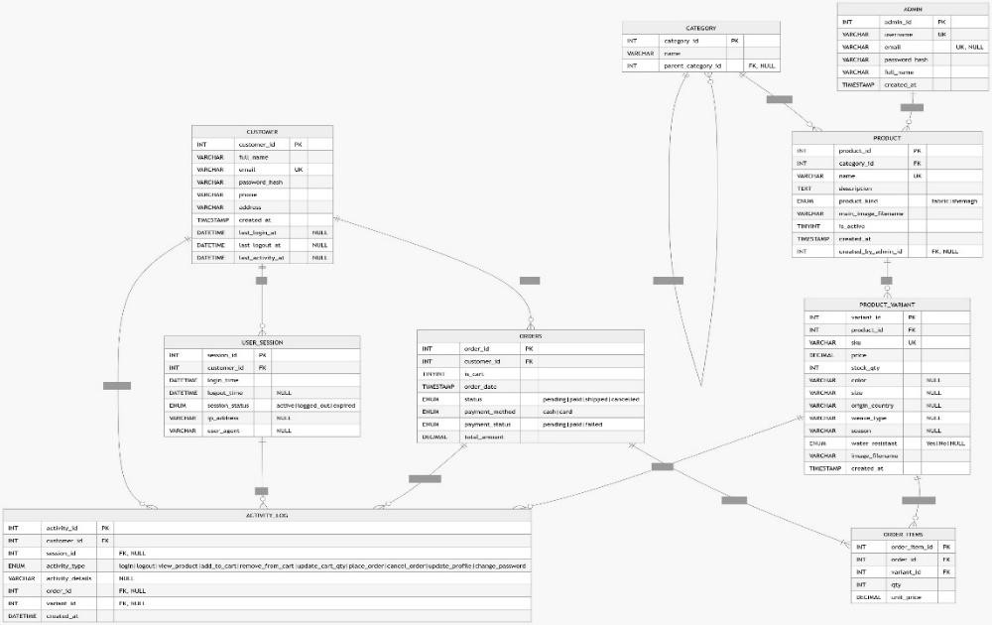

Entity-Relationship Design
The Entity-Relationship design explains how tables interconnect, using primary and foreign keys. Relationships are Crucial to ensure that the database runs as one mind.
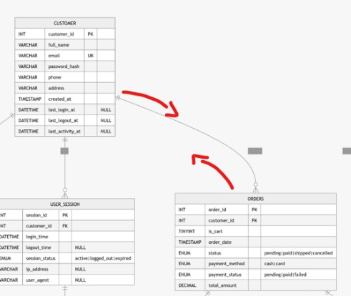
    - Customer to Orders relationship: One customer can create multiple orders.
    - Orders to Order items relationship: One order can contain many items.
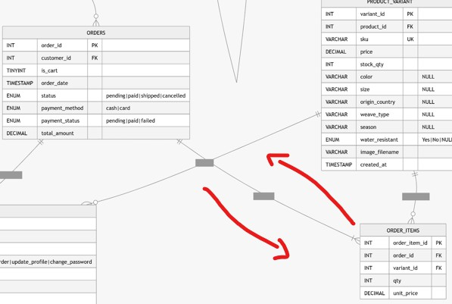

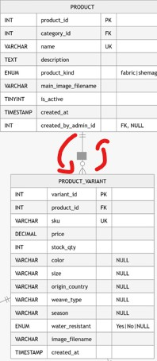
    - Product to Product Variant relationship: One product can have multiple variants.
    - Category to Product relationship: Each product belongs to a category.
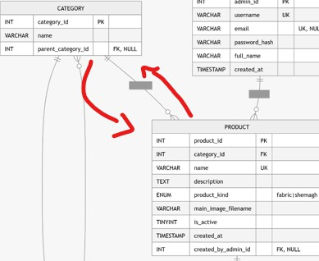
    - Customer to Session and Activity Log relationships: A customer can have multiple sessions and activity records.
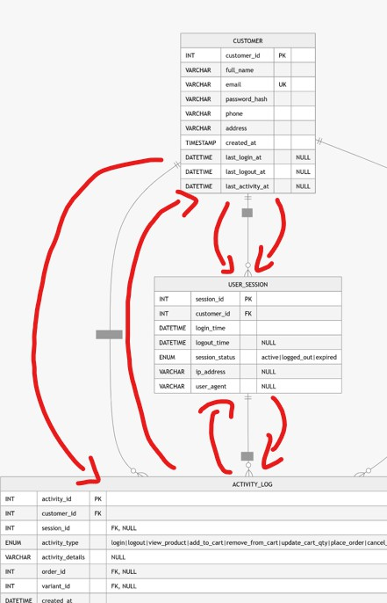
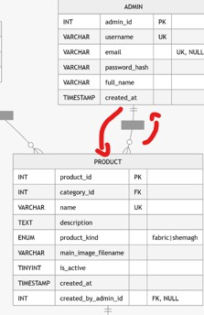
    - Admin to product relationship: An Admin can create or manage products.

User Features

Product Listing
User has a display of varieties of available products in an organized fashion, where each product includes an image and basic information. A cart icon is also displayed allowing fast access to
check out. Ensuring ease and fast browsing.
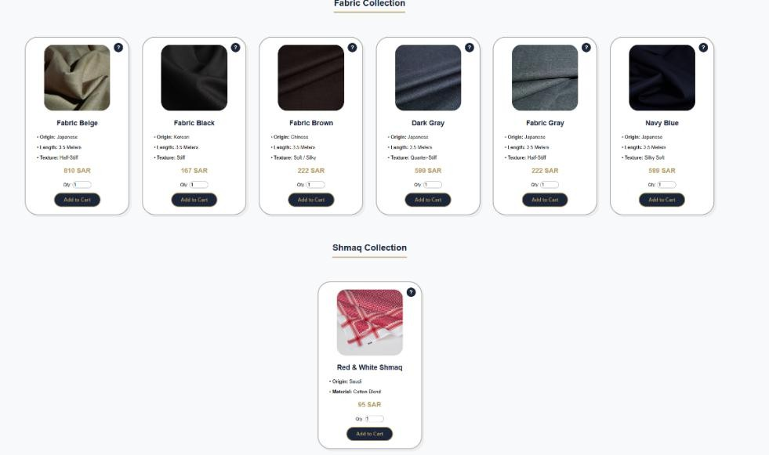

Product Details Page
When the user clicks on a product, they are directed to a detailed view of the selected product providing comprehensive information. Includes price, availability, and help.
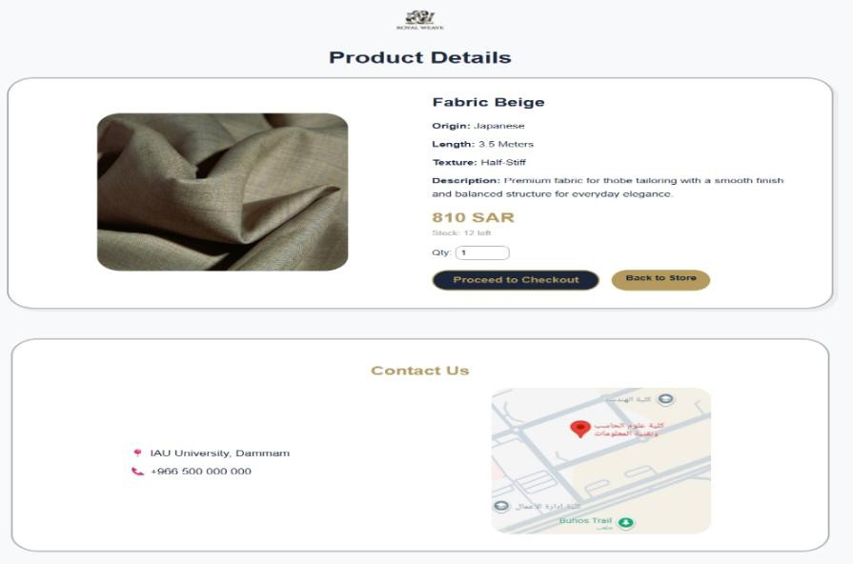

Cart and Checkout
The cart and checkout pages allow users to manage selected items in one place. Users can modify item quantities, delete individual items, clear the cart or proceed with selected items. The cart is connected to the database using PHP, allowing products added by the user to be stored and retrieved dynamically. JavaScript also supports the cart interface and improves user interaction.
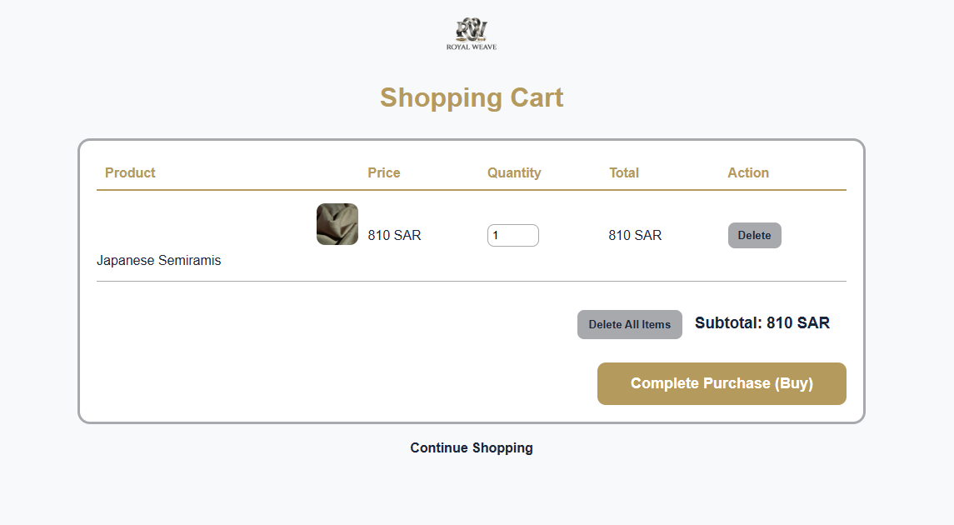

Navigation Flow
The navigation flow is designed to be as straightforward as possible. Ensuring a user-friendly environment. Clicking on a product directs the user to a details page, from which they can
proceed to check out. Also, users can access the checkout page and add the selected product to
the cart by simply clicking on the cart icon. Additionally, a Contact Us page is accessible through the menu.
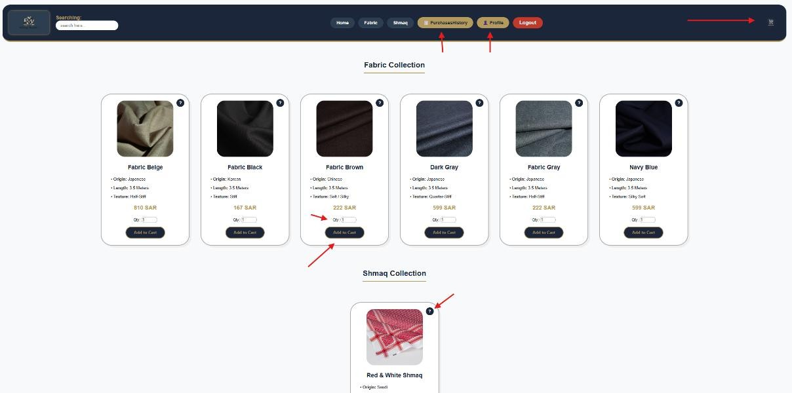

User Account and Purchase History

The user side includes login, signup, profile editing and purchase history pages. These features allow users to access their accounts, update their personal information and view previous purchases. This makes the website more complete and closer to a real e-commerce system.

Contact Us Page
Contact Us page gives the user information regarding the location and a map for better visualization. Enhancing credibility.
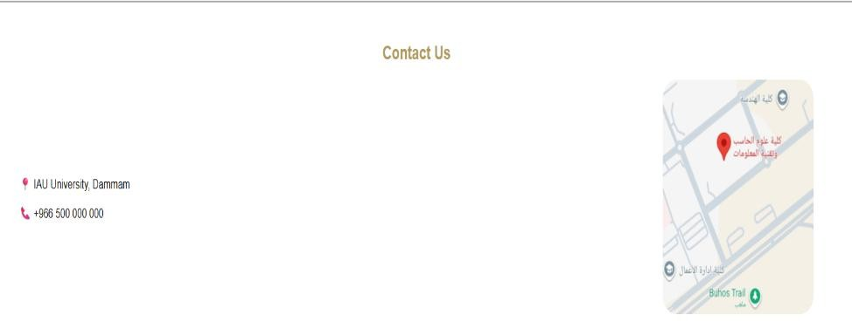

Admin Features

Product Management
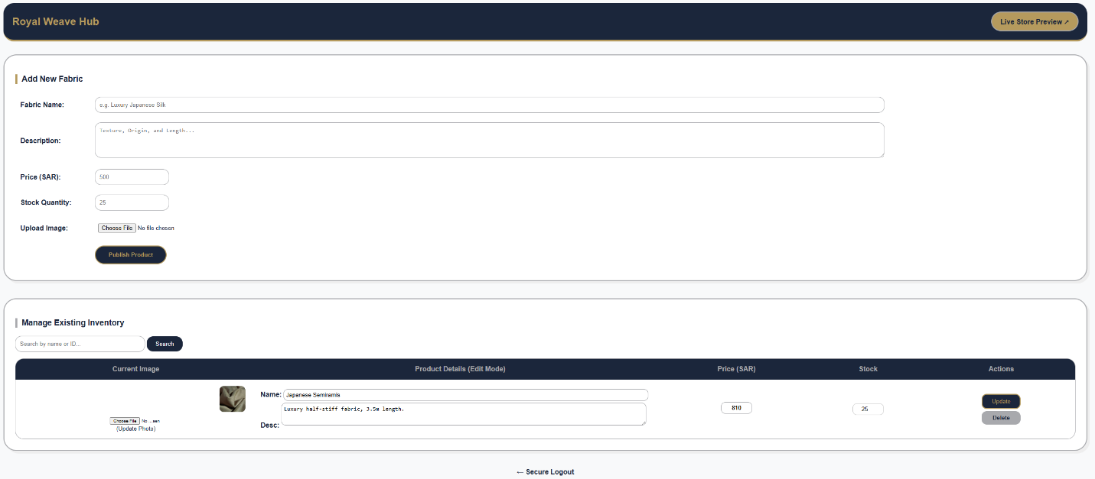
Admin control panel has full control over product management. An Admin can add new products, add their details and upload the images needed. Also, modifying existing products that includes updating their images and deleting unneeded products.

Search Functionality
Admin control panel includes a special search feature that allows an admin to quickly locate specific products. Improving efficiency when managing large numbers of products.

Admin Navigation Flow
The admin navigation flow begins with accessing the admin control panel, then logging in using the admin credentials. From there, the admin can perform actions such as adding, modifying or deleting products.
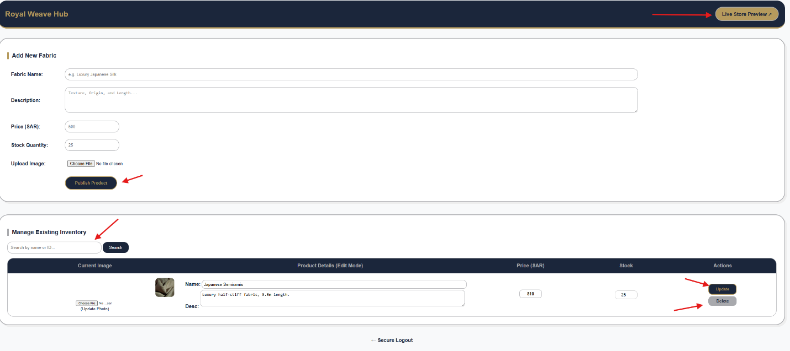

Admin Input Validation
JavaScript validation was added to the admin page to prevent incorrect product data from being submitted. The validation checks that required fields are not left empty, product names do not contain only numbers, category selection is valid, prices and quantities are positive values and invalid negative numbers such as -1 are rejected. This helps reduce incorrect input before the form reaches the PHP and database side.

Admin Logout
After completing the necessary tasks, the admin can securely log out of the system. Maintaining security and preventing unauthorized access.

Fulfilled Requirements

Description

It successfully implements the core functionalities of an e-commerce web application. Users can browse products, view detailed product information, add products to the cart and complete the checkout process. The system also supports user account functionalities including login, signup, profile editing and purchase history viewing.
On the admin side, the control panel allows administrators to add, edit, delete and manage products dynamically using PHP and the database system. Product search functionality was also implemented to improve product management efficiency.

JavaScript Validation

JavaScript validation was integrated into the admin page to ensure that invalid data cannot be submitted easily. The validation checks include preventing empty fields, invalid category selection, number-only product names and negative values such as “-1” in price or stock quantity fields.

Tasks That Are Not Included

Task-1: Online payment gateway integration
Task-2: Email verification system
Task-3: Product recommendation system

Admin validation message

Product management page

Login field

Testing Cases

The system was tested using multiple scenarios to ensure that the main functionalities operate correctly. Testing focused on both user-side and admin-side features.

Testing Table
Feature | Test Case | Expected Result | Actual Result
User Login | Enter correct credentials | User logs in successfully | Passed
User Login | Enter incorrect password | Error message displayed | Passed
Product Listing | Open products page | Products display correctly | Passed
Product Details | Click product | Product details page opens | Passed
Cart System | Add product to cart | Product added successfully | Passed
Cart System | Remove product from cart | Product removed successfully | Passed
Checkout | Confirm order | Order stored successfully | Passed
Admin Product Add | Valid product input | Product added successfully | Passed
Admin Validation | Empty required fields | Submission prevented | Passed
Admin Validation | Negative quantity | Validation error displayed | Passed
Search Functionality | Search for product name | Matching products displayed | Passed

The testing process confirmed that the core project requirements function correctly and that validation mechanisms reduce incorrect admin input.

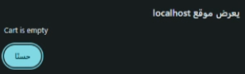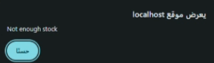
Validation

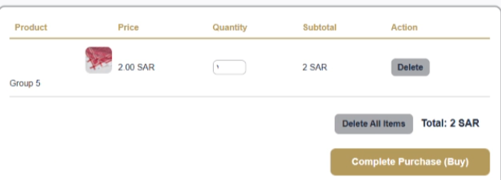
Cart page

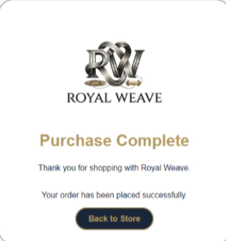
Successful checkout

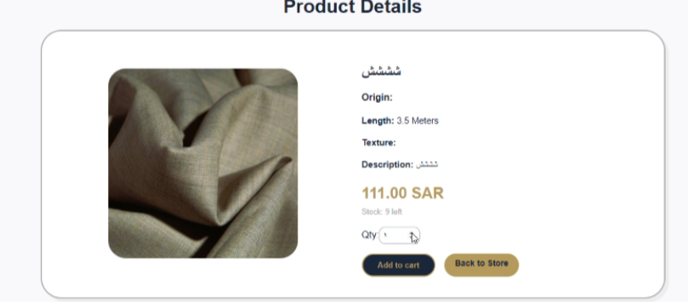
Details
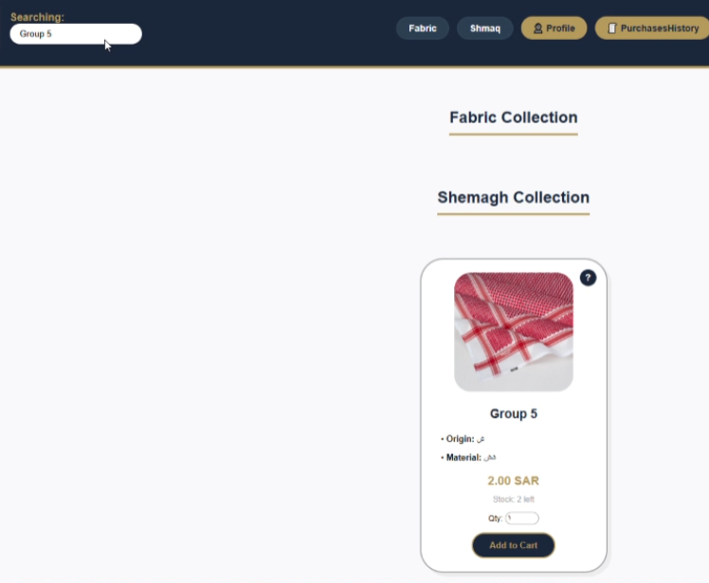
Search Function
Cart
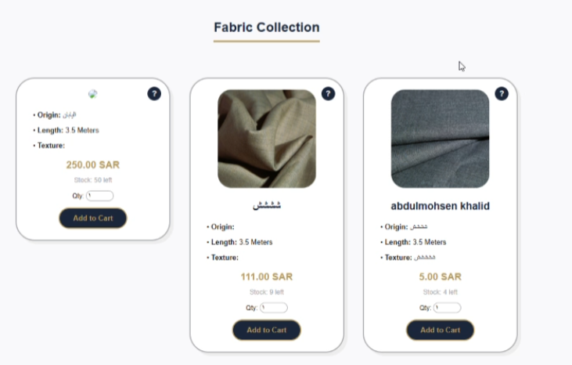
Collection
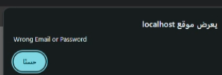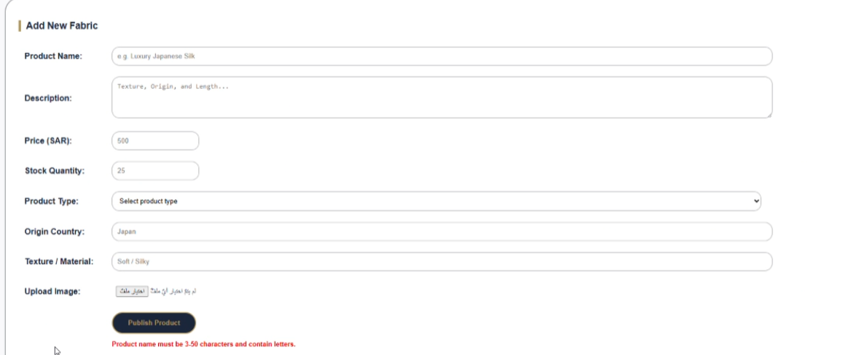
Email Validation Admin Validation
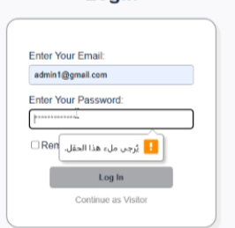

Project Implications

Description

It provides practical experience in developing a complete web-based shopping system by integrating front-end design, database systems, PHP and JavaScript functionality. The project helped improve understanding of how dynamic web applications operate and how different technologies communicate together.

Development process
The development process also strengthened teamwork and collaboration skills, as team members worked on different parts of the project including front-end development, database design and interface functionality.

Future Expansion

It can be expanded in the future into a more advanced e-commerce platform by integrating secure payment systems, improved security mechanisms and additional customer features.

Teamwork and Contribution
We as group 7 worked together in a structured yet flexible manner, ensuring all parts of the project were well executed and integrated. Turki and Abdulmohsen focused primarily on
developing the HTML structure, with Turki contributing to the report writing. Ziyad and Tamim were responsible for designing the database. Mohammed handled the CSS styling, creating a
consisted and user-friendly interface. Despite these primary roles, we as a team maintained a strong collaboration on the project, with all members contributing and reviewing each other’s work. During the later implementation stage, the project was expanded with PHP, database connection and JavaScript functionality. The JavaScript contribution focused especially on improving the admin page through input validation, search support and better interaction, while the PHP and database parts handled dynamic system operations. Despite these primary roles, the team maintained strong collaboration, with all members contributing and reviewing each other’s work.

Conclusion
Royal Weave demonstrates the core features of a shopping web-based system. The project started as a front-end prototype and developed into a more complete e-commerce system with dynamic product management, user account features, cart and checkout functions, purchase history and admin-side validation.

